Chapter 9, Solution 75.

Since 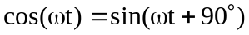, we need a phase shift circuit that will cause the output to lead the input by 90. This is achieved by the RL circuit shown below, as explained in the previous problem.
10 
10 
j10 
j10 
+
V_{i}
−

+
V_{o}
−

This can also be obtained by an RC circuit.

